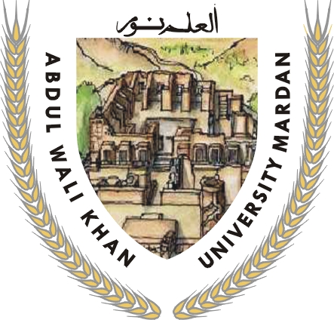
OFFICE OF THE CONTROLLER OF EXAMINATIONS
ABDUL WALI KHAN UNIVERSITY, MARDAN
Ph: 0937-9230641, Fax: 0937-9230638
E-mail: controller@awkum.edu.pk
URL: www.awkum.edu.pk
DATE SHEET
MASTER OF ARTS & MASTER OF SCIENCE (FINAL)
ANNUAL EXAMINATION – 2013
Group .A Time: 09:00 AM to 01:00 PM
Date / Day | Arabic | Mathematics | Physics | Islamiat | Statistics | Computer Science
20/09/2013  Friday | VI | VI | VI | VI | VI | VII
20/09/2013  Friday | Religious Literature | Algebra .II | Quantum Mechanics | Al-Qura’an Translation “2nd Half Commentary along with grammar | Design & Analysis of Experiments | Analysis of Algorithms & Advanced Programming
25/09/2013  Wednesday | VII | VIII | VII | VII | VII | VIII
25/09/2013  Wednesday | Sources of Arabic Language & Literature | Differential Geometry | Electronics | Principles of Islamic Jurisprudence | Statistical Inference | Software Engineering
30/09/2013  Monday | VIII | X | VIII | VIII | VIII | IX
30/09/2013  Monday | Literature of Undalus & overseas | Mathematical Statistics | Solid State Physics | Islam & Other worlds Religions | Regression Analysis & Econometrics | Compiler Construction
04/10/2013  Friday | IX | XI | IX | IX | IX | X
04/10/2013  Friday | History of Arabic Literature | Numerical Analysis | Nuclear Physics | Kalam & Philosophy of Islam / Islamic contemporary Muslim, s worlds | Multivariate Analysis | E-Commerce
09/10/2013  Wednesday | X | XV | X | X | XII | XI
09/10/2013  Wednesday | Islamic Literature and Criticism | Hydrodynamics & Differential Equations | ******* | Islamic Economics /  Islamic Politics / Islamic Science | Population Studies | Artificial Intelligence
Group .B
Date / Day | Economics | Pashto | Political Science | History | English | Urdu | International Relations
21/09/2013  Saturday | VI | VI | VI | VI | VI | VI | VI
21/09/2013  Saturday | Econometrics | Modern Poetry | Political Development, Social Change & Research Methodology | Philosophy of History & Historiography | Poetry-II | Poetry Nazam | Public & international Law
26/09/2013  Thursday | VII | VII | VII | VII | VII | VII | VII
26/09/2013  Thursday | Group I: Development Economics  Group II: Economic Analysis of Project Planning & Management | Modern Prose | Muslim world & its Political Dynamics | Group A- The Holly Prophet, Orthodox Caliphs & Ommayads  Group B- Muslims in South Asia 711-1526 A.D | Novel | Qaseeda, Masnavi & Marsia | Politics of International economic relations
01/10/2013  Tuesday | VIII | VIII | VIII | VIII | VIII | VIII | VIII
01/10/2013  Tuesday | Group I: Managerial Economics  Group II: Human Resources Development | Detailed Study of Khushal | Group A- International Law & Organizations  Group B- Political & Institutional Development in Pakistan  Group C- Western Political Philosophy | Group A- The Abbasids & the Muslims Spain  Group B- Muslims in South Asia 1526-1707 A.D | Drama | Iqbaliat | Strategic Studies
05/10/2013  Saturday | IX | IX | IX | IX | IX | IX | IX
05/10/2013  Saturday | Group I: Economy of Pakistan  Group II: Economic System of Islam | Critical Literature Rhetoric | Group A- Foreign Policy Analysis & Foreign Policy of USA, China, India & Pakistan  Group B- Economy of Pakistan  Group C- Muslim Political Philosophy | Group A- The Ottomans  Group B- Muslims in South Asia 1707-1858 A.D | Criticism | Criticism | Foreign Policy of China, India & Afghanistan
10/10/2013  Thursday | X | X | X | X | X | X | X
10/10/2013  Thursday | Group I: Agricultural Economics  Group II: Industrial Economics | Essay | Group A- Politics of International Economic Relations  Group B- Pakistan in world Affairs  Group C- Contemporary Political Thoughts | Group A- Modern Muslims States with special reference to Egypt, Turkey, Saudi Arabia & Iran  Group B- Pakistan since 1947 | English Language Teaching | Essay | International politics of Middle East
11/10/2013  Friday | XI |  |  | XI | XI |  | XI
11/10/2013  Friday | Group I: International Economics  Group II: Operation Research in Mathematics programming | ******* | ******* | Group A- Islam in Africa  Group B- Genesis of Pakistan 1906-1947 A.D | ************ | ******* | International Politics of South Asia
 |  |  |  | XII | XII |  | XII
12/10/2013  Saturday |  |  |  | Group A- Muslim Political thoughts  Group B- India since 1947 A.D | ************* |  | South–East Asia in world affairs

Controller of Examinations
Abdul Wli Khan University, Mardan

Prepared by: Istefar ali

